Web Blog Using WordPress
AIM:
To create a web blog using WordPress to demonstrate HTML elements such as anchor tags, title tags, and other basic web features.
ALGORITHMS:
- Start.
- Open WordPress and log in to the dashboard.
- Create a new website or blog.
- Select and activate a suitable theme.
- Create a new post or page.
- Enter the title and content of the blog.
- Add an anchor tag to link to another page or a section of the same page.
- Set the page title using the appropriate title field or HTML title element, depending on the editor.
- Add headings, paragraphs, images, and hyperlinks as required.
- Preview the page and verify that the links and title work correctly.
- Publish the blog.
- Stop.

CODE:
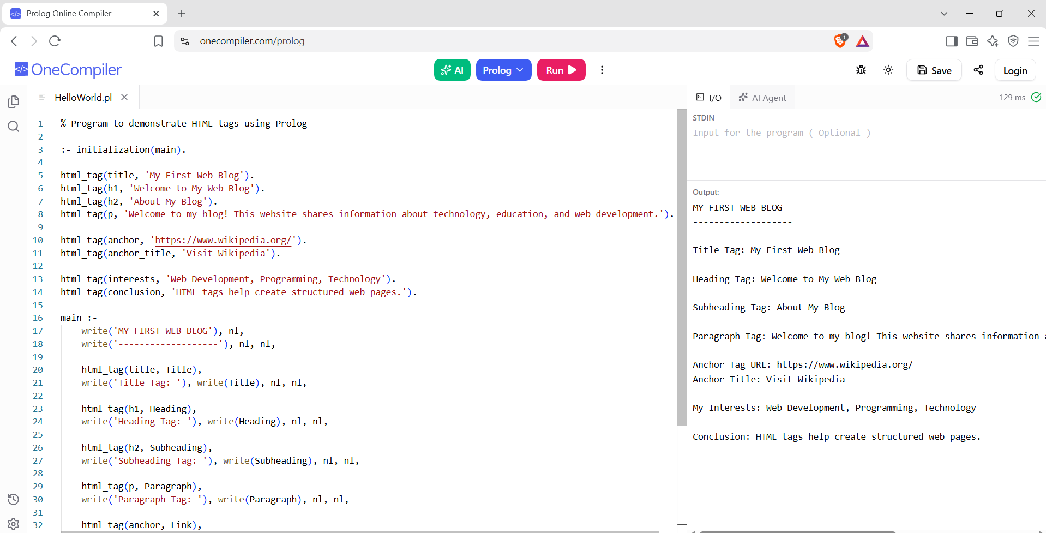

RESULTS:
A web blog is created successfully, demonstrating anchor tags, title tags, hyperlinks, and other basic web elements.

